**Software Requirements Specification**

**Brendan College, Alejandro Fernandez, Charles Karlson, Samantha Maddox**

**Project 1: Group Matching App**

**COP 4331, Fall 2021**

Contents of this Document

Introduction

* Software to be Produced
* Applicable Standards

Definition, Acronyms, and Abbreviations

Product Overview

* Assumptions
* Stakeholders
* Event Table
* Use Case Diagram
* Use Case Descriptions

Specific Requirements

* Functional Requirements
* Interface Requirements
* Physical Environment Requirements
* Users and Human Factors Requirements
* Documentation Requirements
* Data Requirements
* Resource Requirements
* Security Requirements
* Quality Assurance Requirements

Supporting Material

**Section 1: Introduction**

Software to be Produced:

* myMeet will be a web-hosted Java application with an attached MySQL database. It will allow users to connect with other users, create and join groups, as well as create and join events.

Applicable Standards

* It will exclusively run on a web browser
* All other standards used are in the Project Management Plan

Definitions, Acronyms, and Abbreviations

* None

**Section 2: Product Overview**

Assumptions:

* Users are 18 or older
* All modules (database, website, and application) are compatible

Stakeholders:

* Users: will be using the application
* Programming team: will need to have a functioning program to receive a grade
* Professors/TAs: will receive the program and provide grades to the programming team

Event Table:

|  |  |  |  |
| --- | --- | --- | --- |
| **Event Name** | **External Stimuli** | **External Responses** | **Internal data and state** |
| Create user | User creates profile | Confirmation of creation | Add to table |
| Delete user | User deletes user | Confirmation of deletion | Drop from table |
| Create group | User create group | Confirmation of creation | Add to table |
| Delete group | User deletes group | Confirmation of deletion | Drop from table |
| Create event | User creates event | Confirmation of creation | Add to table |
| Delete event | User deletes event | Confirmation of deletion | Drop from table |

Use Case Diagram

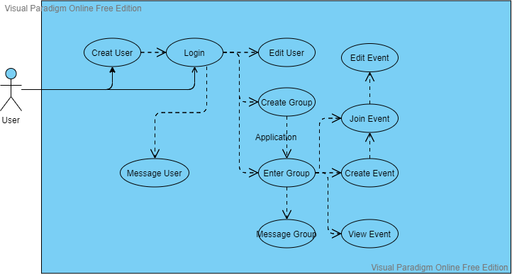

Use Case Descriptions:

* Create user
* Login
  + Once users log in, they have access to all normal functions of the program

**Section 3: Specific Requirements**

|  |
| --- |
| No: 1 |
| Statement: Users shall be able to manage profiles |
| Source: Basic functionality |
| Dependency: User must have a valid account or be able to create one |
| Conflicts: None |
| Supporting Materials: Above |
| Evaluation Method: User is able to influence the database |
| Revision History: n/a |

|  |
| --- |
| No: 2 |
| Statement: Users shall be able to manage groups |
| Source: Basic functionality |
| Dependency: User must have a valid account |
| Conflicts: None |
| Supporting Materials: Above |
| Evaluation Method: User is able to influence the database |
| Revision History: n/a |

|  |
| --- |
| No: 3 |
| Statement: Users shall be able to manage events |
| Source: Basic functionality |
| Dependency: User must have a valid account and be a part of a group |
| Conflicts: None |
| Supporting Materials: Above |
| Evaluation Method: User is able to influence the database |
| Revision History: n/a |

3.1 Functional Requirements

* Sanitize text inputs, reject bad words
* Arrest spam attempts
* Allow users to create, manage, and delete profiles, groups, and events

3.2 Interface Requirements

* Read and write to/from the database via the website (timing/sync issues not present)
* Data will be accurate to the latest refresh
* Information that comes as a result of user interaction with the application will accordingly be updated in the database

3.3 Physical Environment Requirements

* Java application will be hosted on a website, which will be hosted on a third-party hosting service
* Database will be hosted on Eustis

3.4 User and Human Factors Requirements

* System will support one class of user (substate for administration of groups)
* Simple users, assumed average skill level
* Simple how-to page on how to use myMeet
* Accessibility options will be through the user’s own browser and OS
* System will detect and arrest spamming attempts (e.g. creating multiple users, groups, events)
* System will only allow registration of those at or above the appropriate age

3.5 Documentation Requirements

* Simple online page on how to use myMeet
  + Users assumed to be an average social media user (any age)
  + Web page (or PDF on web page) hosted to show normal functions of the application
    - How to interact with other users
    - How to interact with groups
    - How to create and administrate groups
    - How to interact with events
    - How to create and administrate events

3.6 Data Requirements

* Interest matching arithmetic will need to be defined at some point

3.7 Resource Requirements

* Team of 4 developers to build and maintain
* Communal spaces on the UCF campus will be used for physical meetings
* Discord will be used for virtual communication
* No monetary funding
* Open-source software
* Completed by end of semester, fall 2021

3.8 Security Requirements

* Database must not be accessible by users or third parties
  + Only official requests (e.g. by the program or by developers)
* Sensitive information (e.g. passwords) will be hashed
* Users will be isolated from other users, only able to make requests to the program for the program to read/write the database
* Users will have security questions and answers for resetting a password
* Daily backups stored onsite
* Weekly backups stored offsite

3.9 Quality Assurance Requirements

* Functionality above all else
* Concurrent same user logons will kick the oldest user logged in
* Hard user timeouts
* Weekly downtime for maintenance
* Reliability and security will be project goals

**Section 4: Supporting Material**

* None